LOYOLA HIGH SCHOOL, PATNA-10

2011-2012
INFORMATICS PRACTICES
PRACTICAL ASSIGNMENT FILE
AISSCE-2012
BY:-
ABHINAV ANURAG
CLASS:- 12 A
BOARD’S ROLL NO :-

PRACTICAL ASSIGNMENT -1

Q:-Design an application using class and object and methods to check a given number is prime ,palindrome or perfect.

- Designing components:-

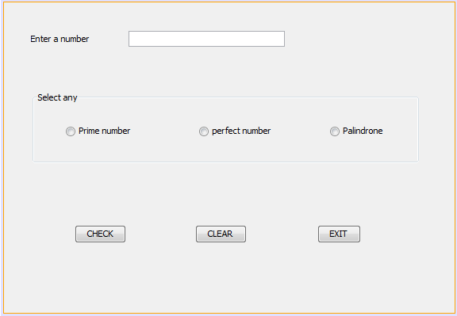

- Property settings:-
Controls | Property | Settings
jLabel1 | Name | jLabel1
 | Text | Enter a number
jTextField1 | Name | tf1
 | Text | “ ”
jPanel1 | Name | pnl 1
 | Border | Titled
 | Title | Select any
jRadiobutton1 | Name | rdb1
 | Text | Prime Number
 | Button group | bg1
jRadiobutton2 | Name | rdb 2
 | Text | Perfect Number
 | Button group | bg1
jRadiobutton3 | Name | rdb3
 | Text | Palindrome
 | Button group | bg1
jButtongroup1 | Name | bg1
jButton1 | Name | btn1
 | Text | CHECK
Jbutton2 | Name | btn2
 | Text | CLEAR
jButton3 | Name | btn3
 | Text | EXIT

- Coding:-

- Importing classes:-

import javax.swing.JOptionPane;

- Coding for making the panel inactive when no input is given by the user:-

private void forNoText(java.beans.PropertyChangeEvent evt) {
String a=tf1.getText();
if (a.equals(""))
pnl1.setEnabled(false);
}
- coding on “CHECK” button:-

private void btn1ActionPerformed(java.awt.event.ActionEvent evt) {
try{
String a=tf1.getText();
if (a.equals(""))
pnl1.setEnabled(false);
checkNo obj=new checkNo();
int b=Integer.parseInt(tf1.getText());
if(rdb1.isSelected()==true)
obj.checkPrime(b);
if(rdb2.isSelected()==true)
obj.checkPerfect(b);
if(rdb3.isSelected()==true)
obj.checkPalindrone(b);

}
catch(Exception e)
{JOptionPane.showMessageDialog(null,"please check if number entered for observation is an integer");}
}

- coding on “CLEAR” button:-

private void btn2ActionPerformed(java.awt.event.ActionEvent evt) {
tf1.setText("");
rdb1.setSelected(true);
rdb2.setSelected(false);
rdb3.setSelected(false);
}
- coding on “exit” button:-
private void btn3ActionPerformed(java.awt.event.ActionEvent evt) {
System.exit(0);
}

- creating class for above program:-

public class checkNo{
public void checkPrime(int a)
{
int p=0;int z;
for(int i=1;i<=a;i++)
{
if(a%i==0)
p++;
}
if(p==2)
JOptionPane.showMessageDialog(null,""+a+" is a prime number.");
else
JOptionPane.showMessageDialog(null,""+a+" is not a prime number.");
}
public void checkPerfect(int a)
{
int p=0;
for(int i=1;i<a;i++)
{
if(a%i==0)
p++;
}
if(p==a)
JOptionPane.showMessageDialog(null,""+a+" is a perfect number.");
else
JOptionPane.showMessageDialog(null,""+a+" is not a perfect number.");
}
public void checkPalindrone(int n)
{
int r=0;int rev=0;
int m=n;int q=n;
while(q>0){
r=q%10;
rev=rev*10+r;
q=q/10;
}
if(rev==m)
JOptionPane.showMessageDialog(null,""+n+" is a palindrone.");
else
JOptionPane.showMessageDialog(null,""+n+" is not a palindrone.");
}}
- Output :-
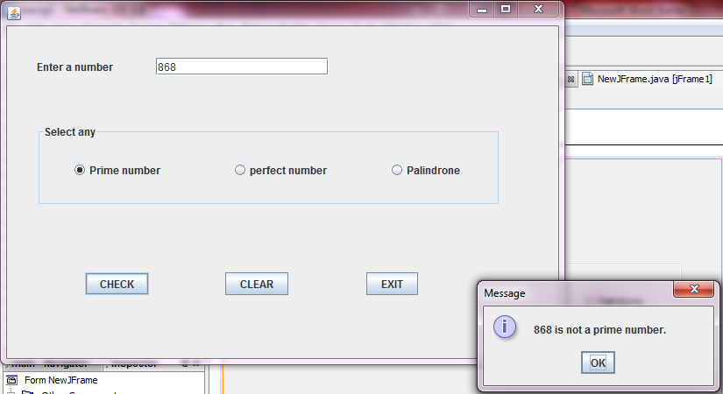

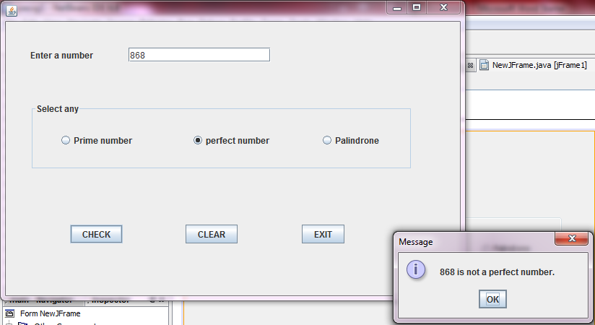

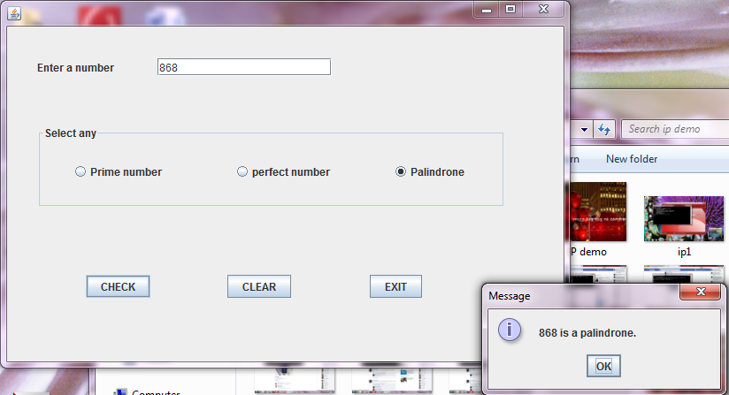

PRACTICAL ASSIGNMENT-2

Q:-Design a notepad application using NetBeans IDE where users can do append a text, insert new text, replace text, cut, copy and paste.

- Designing components:-

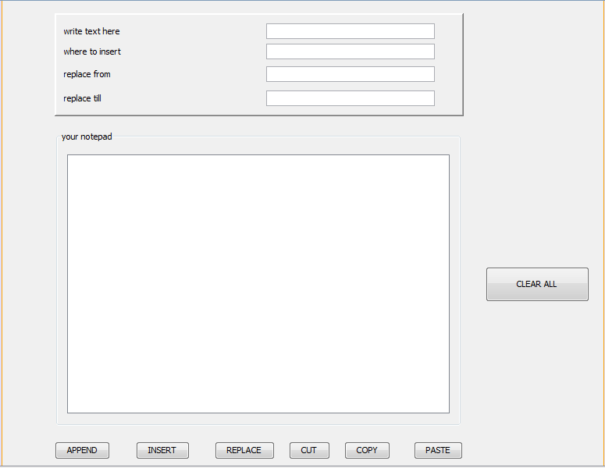

- Property setting:-
Component | Property | Settings
jPanel1 | Name | Pnl1
 | Border | BevelBorder
jTextfield1 | Name | Text1
 | Text
jTextfield2 | Name | Tpos
 | Text
jTextfield3 | Name | Tstart
 | Text
jTextfield4 | Name | Tend
 | Text
jLabel1 | Name | jLabel1
 | Text | Write text here
jLabel2 | Name | jLabel2
 | Text | Where to insert
jLabel3 | Name | jLabel3
 | Text | Replace from
JLabel4 | Name | jLabel4
 | Text | Replace till
jPanel2 | Name | Pnl2
 | Border | Titled
 | Title | Your notepad
jTextarea1 | Name | jScrollPane1
 | Text
jButton1 | Name | Bttnappend
 | Text | APPEND
jButton2 | Name | Bttnreplace
 | Text | REPLACE
jButton3 | Name | Bttnpaste
 | Text | PASTE
jButton4 | Name | Bttncut
 | Text | CUT
jButton5 | Name | Bttninsert
 | Text | INSERT
jButton6 | Name | Bttncopy
 | Text | COPY
jButton7 | Name | Clear
 | Text | CLEAR ALL

- Coding:-
- On APPEND button:-
private void bttnappendActionPerformed(java.awt.event.ActionEvent evt) {
String txt=text1.getText();
ta1.append(txt);

}
- On INSERT button:
private void bttninsertActionPerformed(java.awt.event.ActionEvent evt) {
String s=text1.getText();
int pos=Integer.parseInt(tpos.getText());
ta1.insert(s, pos);
}
- On REPLACE button:-

private void bttnreplaceActionPerformed(java.awt.event.ActionEvent evt) {
String s=text1.getText();
int spos=Integer.parseInt(tstart.getText());
int epos=Integer.parseInt(tend.getText());
ta1.replaceRange(s, spos, epos);
}

- On CUT, COPY & PASTE buttons:-

private void bttncutActionPerformed(java.awt.event.ActionEvent evt) {
ta1.cut();
}
private void bttncopyActionPerformed(java.awt.event.ActionEvent evt) {
ta1.copy();
}
private void bttnpasteActionPerformed(java.awt.event.ActionEvent evt) {
ta1.paste();
}
- On clear all button:

private void clearActionPerformed(java.awt.event.ActionEvent evt) {
text1.setText("");
tpos.setText("");
tstart.setText("");
tend.setText("");

- Output:-

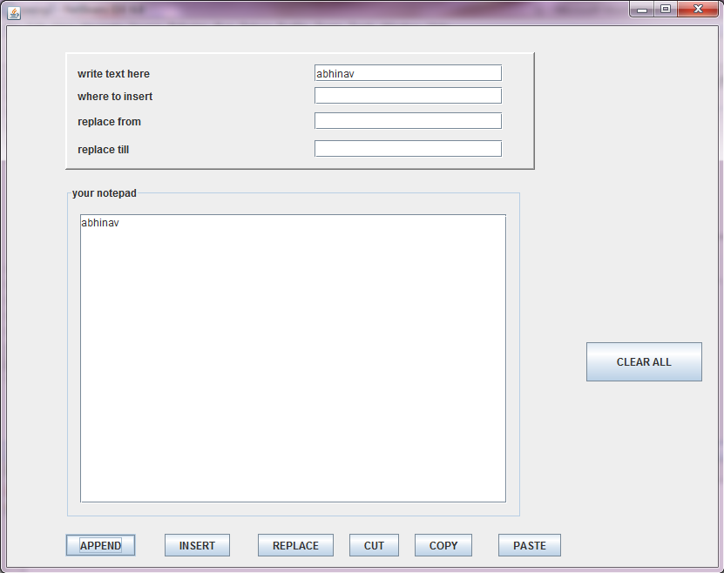

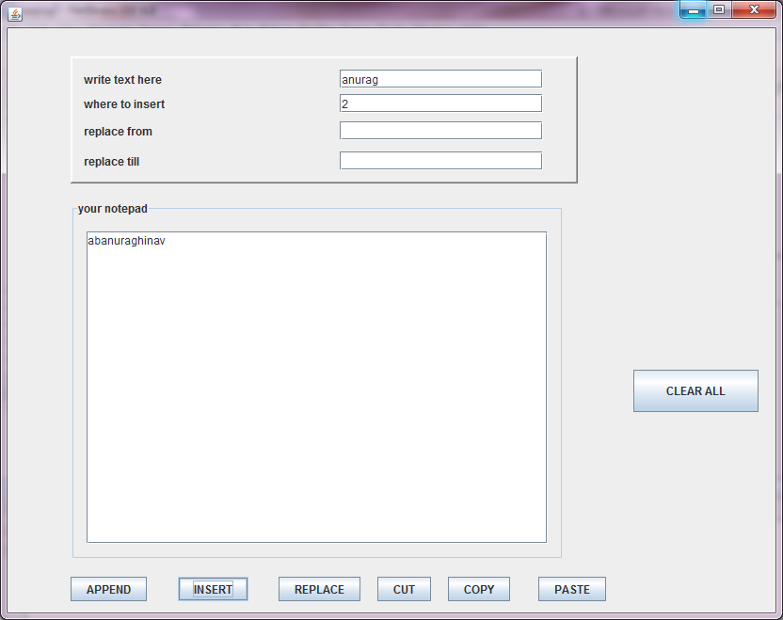

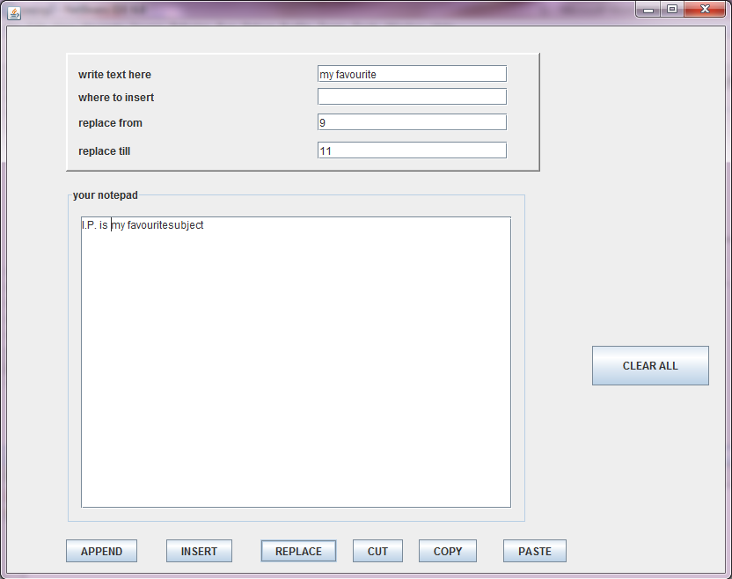

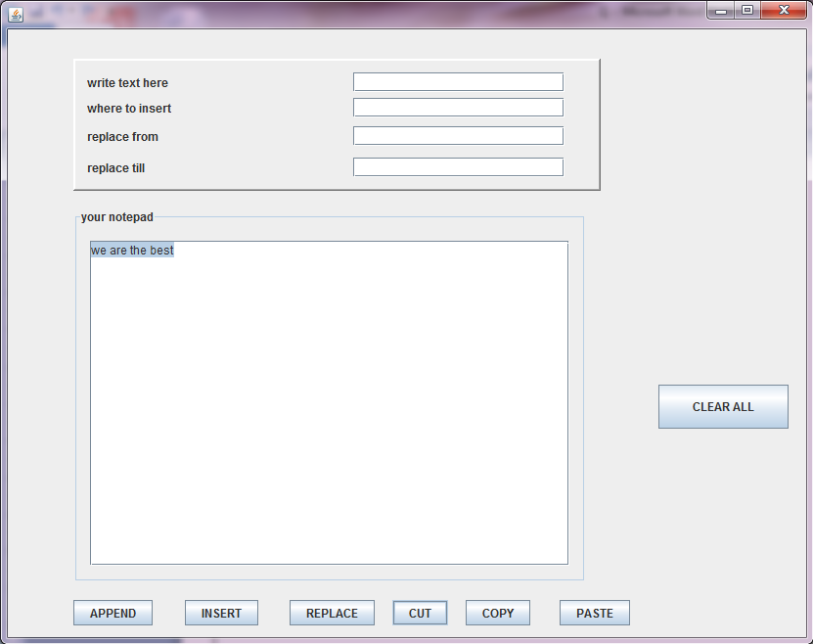

PRACTICAL ASSIGNMENT-3

Q:-Design a data connectivity application that fetches data from EMPL table and has an interface as given below:-
- The user should be able to choose any fields in the select list.
- The sort criterion should be decided by user for order by clause
- The filtering condition for where clause should be specified by user for job and/or deptno fields.
- As per the specified details the data should be fetched from EMPL table and shown in tabular format.

- Designing components:-

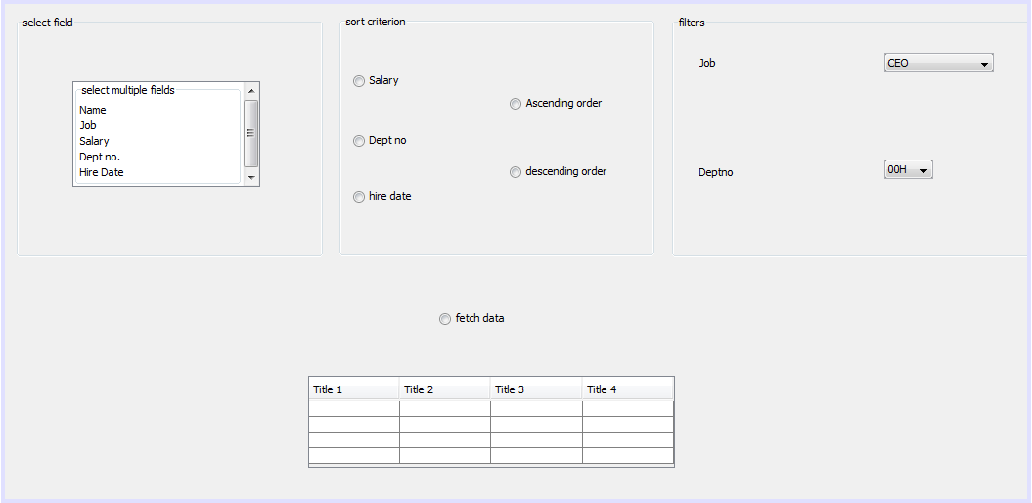

- Property setting:-
Component | Property | Settings
jLabel1 | Name | jLabel1
 | Text | Job
jLabel2 | Name | jLabel2
 | Text | Deptno
jPanel1 | Name | jPanel2
 | Border | Titled
 | Title | Select field
jPanel2 | Name | jPanel2
 | Border | Titled
 | Title | Sort criterion
jPanel3 | Name | jPanel3
 | Border | Titled
 | Title | Filters
jRadiobutton1 | Name | rbsalary
 | Text | Salary
 | Button group | buttonGroup1
jRadiobutton2 | Name | rbdesc
 | Text | Descending order
 | Button group | buttonGroup1
jRadiobutton3 | Name | Rbasc
 | Text | Ascending order
 | Button group | buttonGroup1
jRadiobutton4 | Name | Rbdeptno
 | Text | Dept no
 | Button group | buttonGroup2
jRadiobutton5 | Name | rbhdate
 | Text | Hire date
 | Button group | buttonGroup2
jRadiobutton6 | Name | rbfetchdata
 | Text | Fetch data
jList1 | Name | lstemployee
 | Table model | Name  Job  Salary  Dept no.  Hire Date
jComboBox1 | Name | Combojob
 | Model | CEO  Member(B.O.D)  Head of dept.  Manager  Engineer  Consultant  Clerk  Peon
jComboBox2 | Name | combodeptno
 | Model | 00H  C001  C002  C003  C004  C005
jTable1 | Name | tableempl
 | Model
jButtongroup1 | Name | buttonGroup1
jButtongroup2 | Name | buttonGroup2

- Coding:-
- Importing classes:-
import javax.swing.JOptionPane;
import java.sql.*;
import javax.swing.table.DefaultTableModel;

- Coding on “fetch data”
Object efld[]=lstemployee.getSelectedValues();
int l=efld.length;
String qr="SELECT";
int i;
String f=(String)efld[0];
qr=qr+f;
for(i=1;i<l;i++){
String f1=(String)efld[i];
qr=qr+","+f1;
}// TODO add your handling code here:
qr=qr+"FROM EMPL";
String flt1,flt2;
flt1=(String)combojob.getSelectedItem();
flt2=(String)combodeptno.getSelectedItem();
if(flt1.compareTo("ANY")!=0&&flt2.compareTo("ANY")!=0){
qr=qr+"WHERE JOB="+flt1+"";
qr=qr+"AND deptno="+flt2;}
else if(flt1.compareTo("ANY")!=0)
qr=qr+"WHERE JOB="+flt1+"";
else if(flt2.compareTo("ANY")!=0)
qr=qr+"WHERE JOB="+flt2+"";
if(rbsalary.isSelected()==true)
qr=qr+"ORDER BY SALARY";
else if(rbdeptno.isSelected()==true)
qr=qr+"ORDER BY deptno";
if(rbhdate.isSelected()==true)
qr=qr+"ORDER BY HIREDATE";
if(rbasc.isSelected()==true)
qr=qr+"asc";
if(rbdesc.isSelected()==true)
qr=qr+"desc";
DefaultTableModel dm=(DefaultTableModel)tableempl.getModel();
try{
Class.forName("java.sql.Driver");
Connection con=DriverManager.getConnection("jdbc:mysql://localHost:3308/employee","root","sanjay");
Statement stmt=con.createStatement();
ResultSet rs=stmt.executeQuery(qr);
int empnostr=0;
String enamestr="";
String jobstr="";
int mgrstr=0;
Date hdatestr=null;
float salstr=0;
float commstr=0;
int deptnostr=0;
while(dm.getRowCount()>0)
dm.removeRow(0);
while(rs.next()){
for(i=0;i<1;++i){
String f1=(String)efld[i];
if(f1.compareToIgnoreCase("Empno")==0)
empnostr=rs.getInt("empno");
else if(f1.compareToIgnoreCase("Ename")==0)
enamestr=rs.getString("ename");
else if(f1.compareToIgnoreCase("job")==0)
jobstr=rs.getString("job");
else if(f1.compareToIgnoreCase("mgr")==0)
mgrstr=rs.getInt("mgr");
else if(f1.compareToIgnoreCase("hiredate")==0)
hdatestr=rs.getDate("hiredate");
else if(f1.compareToIgnoreCase("sal")==0)
salstr=rs.getFloat("sal");
else if(f1.compareToIgnoreCase("comm")==0)
commstr=rs.getFloat("comm");
else if(f1.compareToIgnoreCase("deptno")==0)
deptnostr=rs.getInt("deptno");
}
dm.addRow(new Object[]{empnostr,enamestr,jobstr,mgrstr,hdatestr,salstr,commstr,deptnostr} );
}
rs.close();
stmt.close();
con.close();
}
catch(Exception e){
JOptionPane.showMessageDialog(null,"Error in connectivity");
}

PRACTICAL ASSIGNMENT-4

Table: STUDENT
ADM No | Name | Stipend | Stream | Avgmark | Grade | Class
101 | Karan | 400.00 | Medical | 78.5 | B | 12B
102 | Divakar | 450.00 | Commerce | 89.2 | A | 11C
103 | Divya | 300.00 | Commerce | 68.6 | C | 12C
104 | Arun | 350.00 | Humanities | 73.1 | B | 12C
105 | Sabina | 500.00 | Nonmedical | 90.6 | A | 11A
106 | John | 400.00 | Medical | 75.4 | B | 12B
107 | Robert | 250.00 | Humanities | 64.4 | C | 11A
108 | Rubina | 450.00 | Nonmedical | 88.5 | A | 12A
109 | Vikas | 500.00 | Nonmedical | 92.0 | A | 12A
110 | Mohan | 300.00 | Commerce | 67.5 | C | 12C

- Create above table:

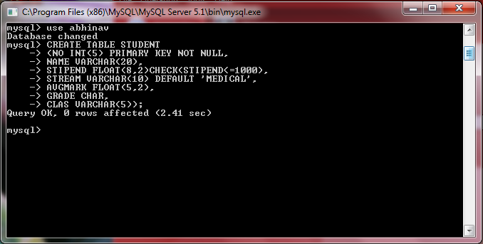

- Insert value in the above table: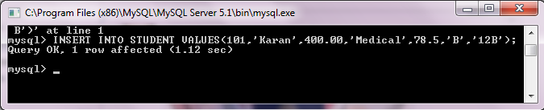
- Select all the nonmedical stream students from STUDENT :-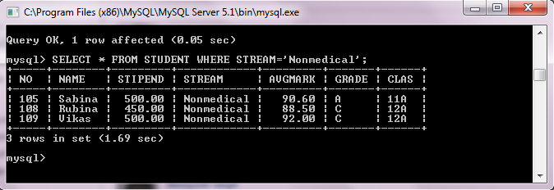
- List all the students sorted by avgmark in descending order:-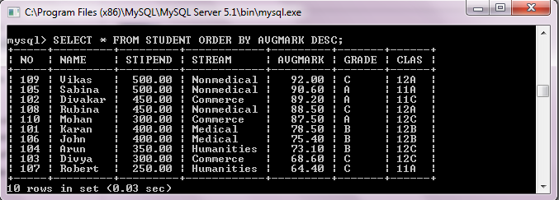

- Display a report listing name, stipend and amount of stipend received in a year assuming that the stipend is paid every month:-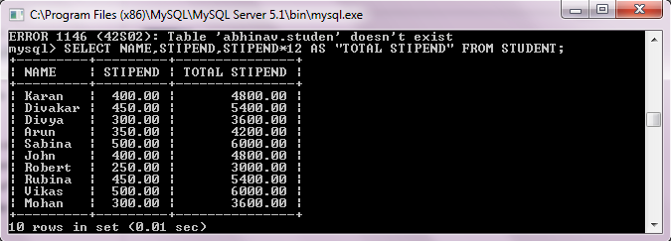
- List the names of those students who are in class 12 sorted by stipend:-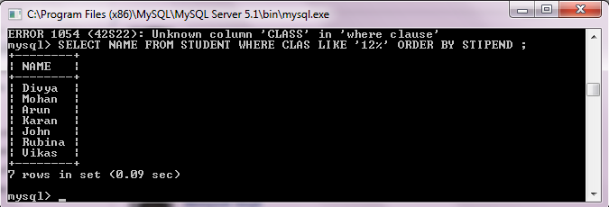
- Increase all the stipends by 100 of all medical and humanities students:-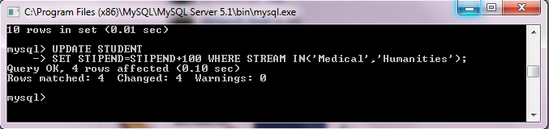
- Display total students in all streams:-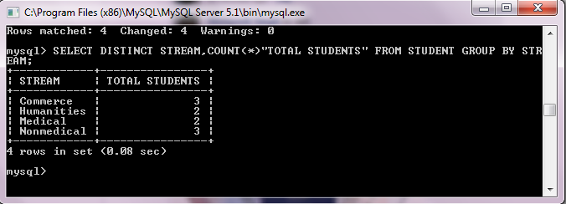
- Add a column city to the given table:-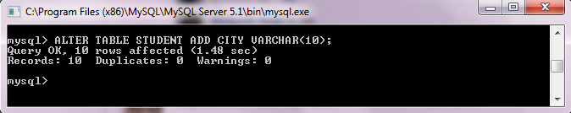
- Change the field name of avgmark to A_mark:- 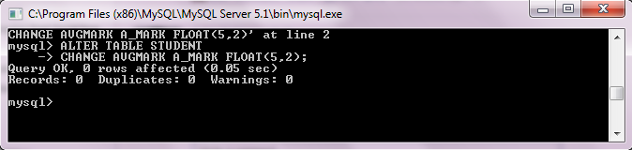

PRACTICAL ASSIGNMENT-5

Write MySql query to create following tables as given details,where one table “programmer” has all the details of different programmers and another table “Company” has all the details of different companies those hired different programmers:-

PROGRAMMER
ID | Pname | Lang
101 | A.kumar | C++
102 | Manish | .net
103 | Amber | Java

COMPANY
Co_ID | CName | ProgID | Place
C104 | Def Pvt.Ltd | 102 | Delhi
C111 | PF Ltd. | 101 | Mumbai
C078 | Base soft. Ltd | 103 | Manglore
C891 | UTL Ltd. | 101 | Kolkata
C555 | Ambas Pvt. Ltd. | 102 | Manglore

    - Display the programmer name,language,company name those are employee of manglore based company

Select p.pname,p,lang,c.cname from programmer p,company c where c.place=’manglore’and p.id=c.progid;

    - Display all company’s details with their programmer’s name

Select c.*,p.pname from programmer p,company c where p.id=c.progid;

    - Count total programmers in each company

Select distinct p.pname,count(p.*)as “total programmers” from programmer p,company c group by c.cname and p.id=c.progid;

    - Give outputs of the following queries:-
        - ALTER TABLE PROGRAMMER ADD RATE DECIMAL(12,2);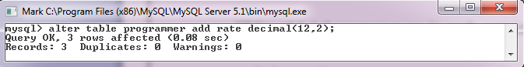

        - UPDATE PROGRAMMER SET RATE=20000.00;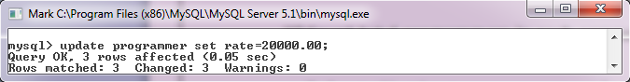
        - SELECT P.*, C.PLACE FROM PROGRAMMER P,COMPANY C WHERE P.ID=C.ProgID;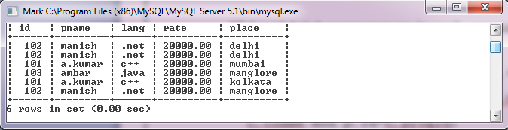

        - SELECT Distinct place, count(*) “Total Companies” FROM COMPANY GROUP BY PLACE; 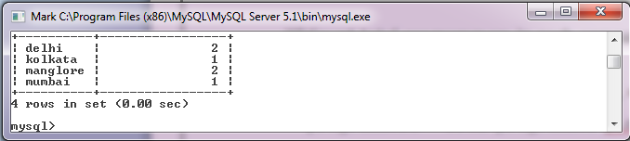

THIS IS TO CERTIFY THAT
MASTER ABHINAV ANURAG
OF CLASS XII-A
ROLL NO ___________________
HAS PERFORMED THESE ASSIGNMENTS WITH
GREAT EFFORT.
I WISH HIM SUCCESS IN HIS LIFE.

PLACE :- _____________
DATE :- TEACHER’S SIGNATURE

PLACE :- ______________
DATE :- INVIGILATOR’S SIGNATURE

OBJECTIVE

The main oblective of this practical assignment file is just to ensure that each and every has come across the expanse of the course very deftfully.
These practical assignments cover all the aspects and concepts which we should have got while studying i.p throughout the year.
It includes the assignments related to:-
- Basic software development
- Matiple radiobutton handling
- Making classes
- Handling various string functions
- Database connectivity
- Various aspects of database handling
This practical assignment file is perfect for giving a finishing touch to our syllabus.
Enjoy browsing through this file…

Conclusion

After doing these practical assignments, one can conclude that java is a very interesting language to learn as nothing but pure brain is used while doing its coding.
This assignment file has really helped us to give the finishing touch to the subject for class 12th.



